PICKLE RICK
Platform – TryHackMe
Difficulty – Easy
Link - https://tryhackme.com/room/picklerick
Tags - Enumeration, Web Exploitation
Description - This Rick and Morty-themed challenge requires you to exploit a web server and find three ingredients to help Rick make his potion and transform himself back into a human from a pickle.
Tools - gobuster
Commands - ls,less,cd,sudo
Walkthrough
Our goal is to find all the 3 ingredients.
1.Deploy the give IP address in your browser, it will open a webpage

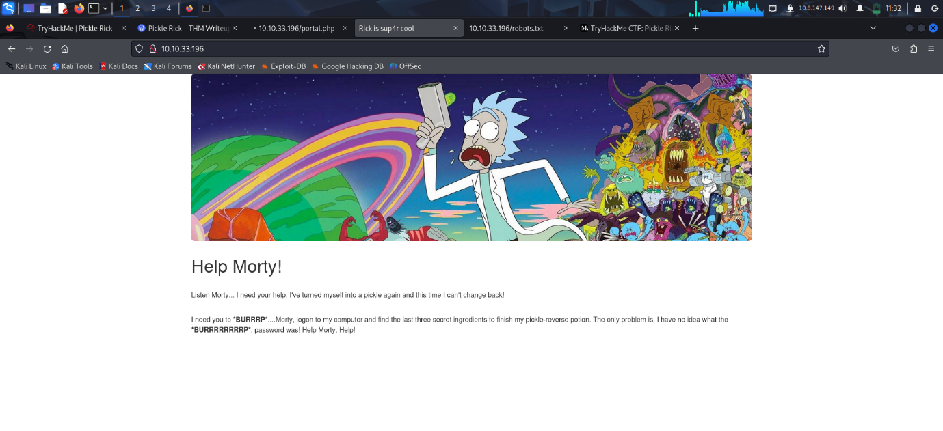
2. View the page source and a login page was mentioned along with a username
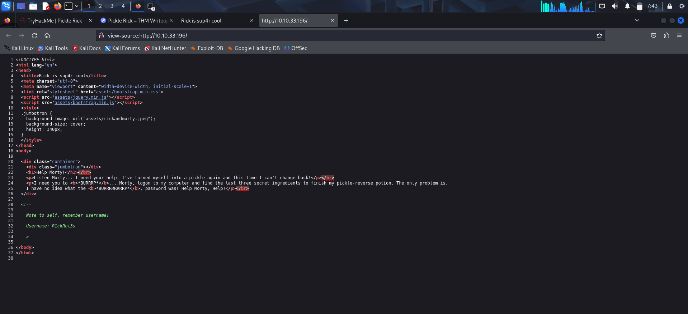
3. Website Enumeration
Using the gobuster tool we will find a login.php page
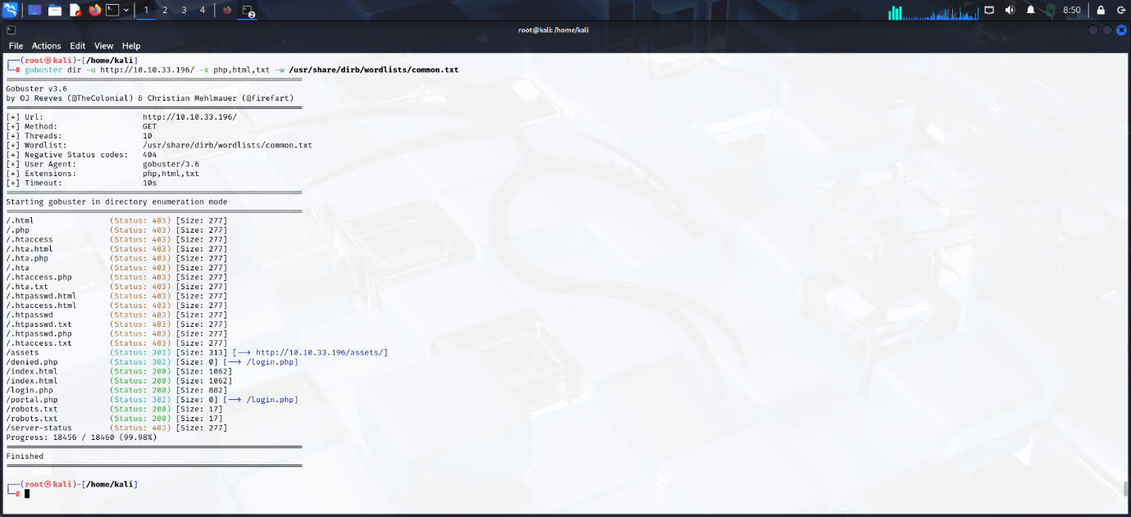
Navigate to the login page and we will see that it requires a password
Go to robots.txt file in the address bar and we will obtain the password
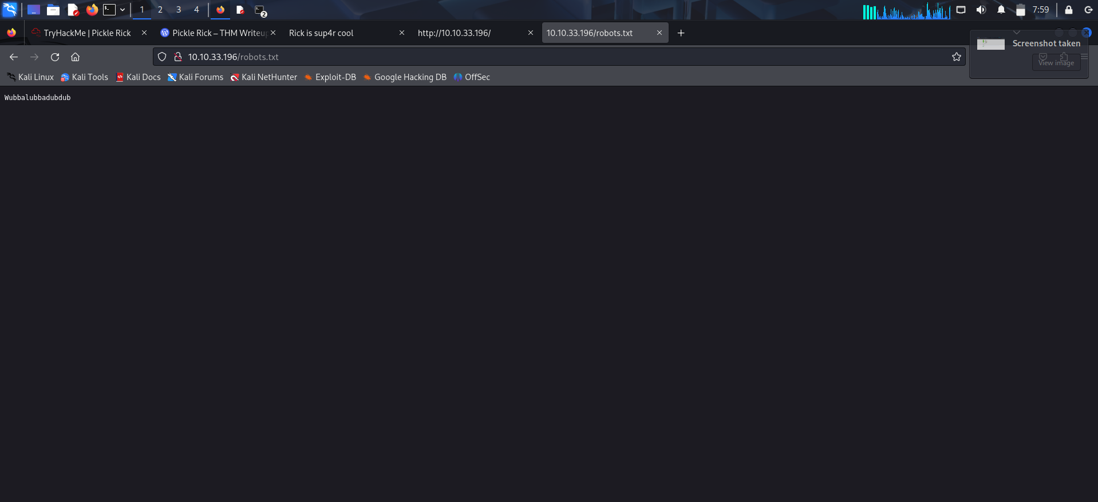
Login into the page using the credentials
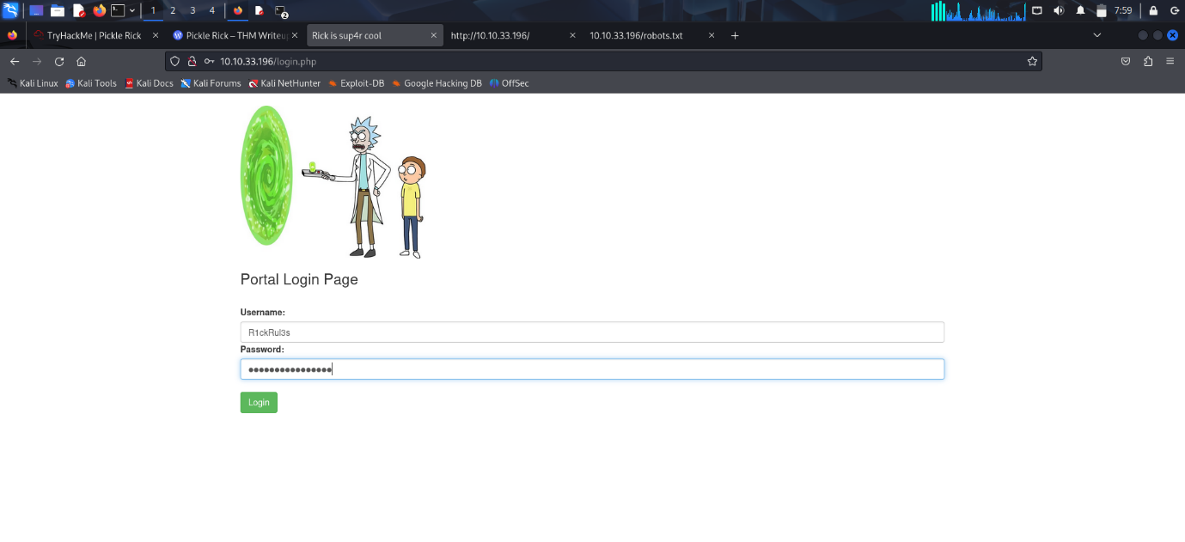
After login a command shell will be present
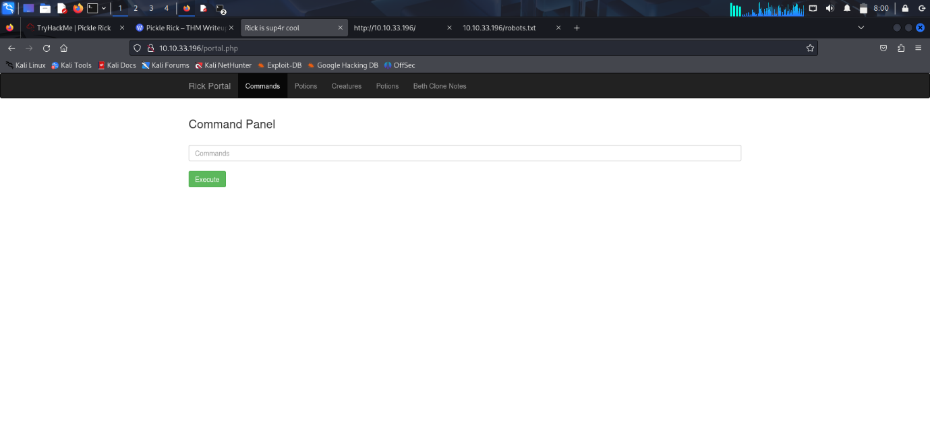
Use the ls command to see the files
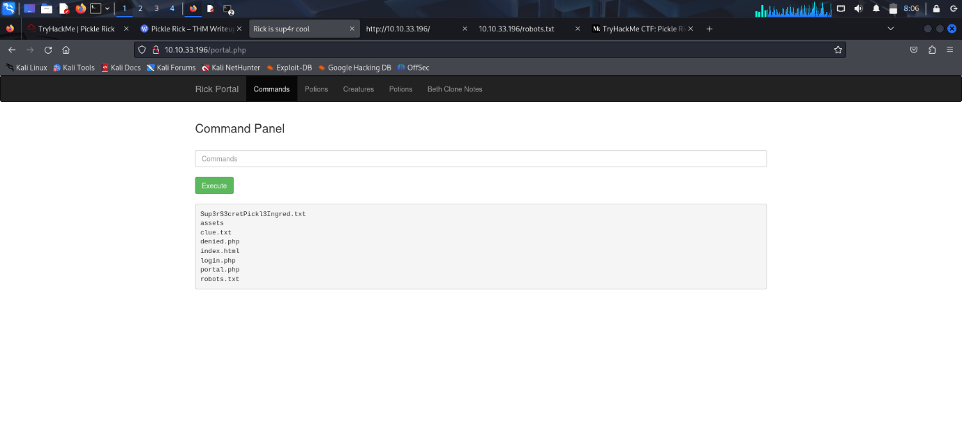

There is a text file named Sup3rS3cretIngred.txt . Use ‘cat’ command to see the contents of the files
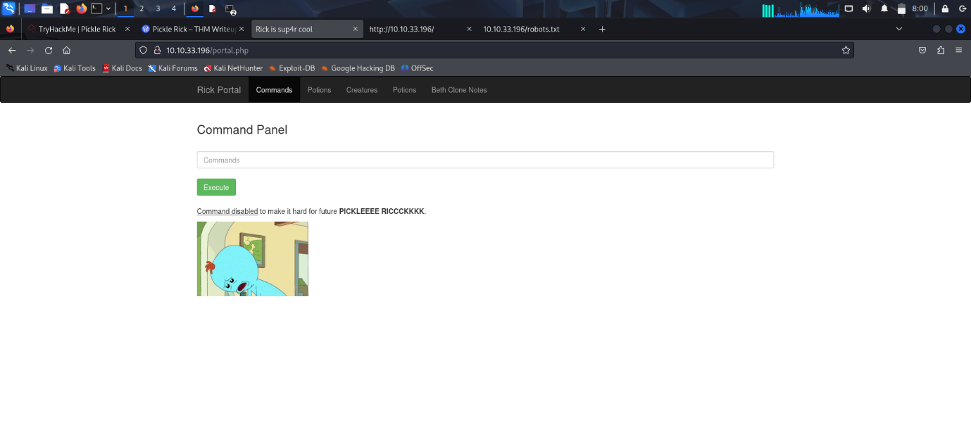
The ‘cat’ command seems to be disabled so use the ‘less’ command
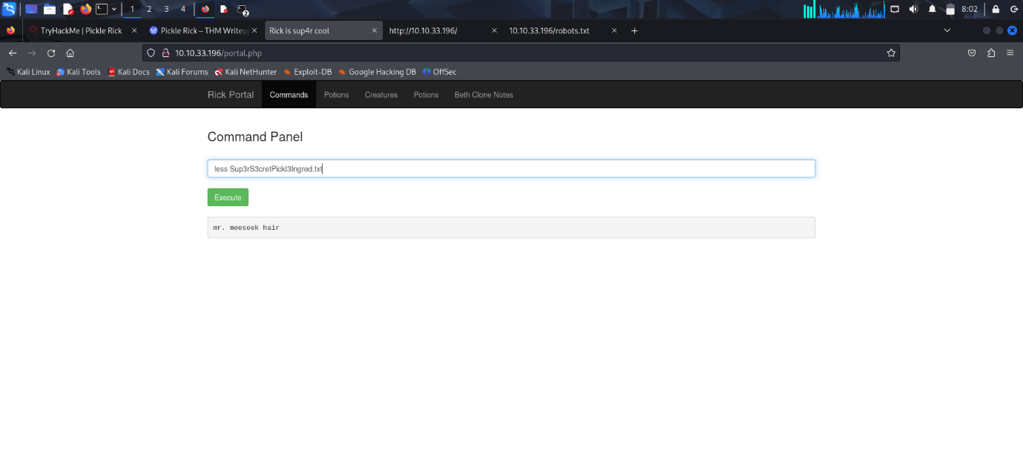
We got the first ingredient – mr. meeseek hair

There was another text named clue.txt

Use ‘less’ command to see the contents of the file
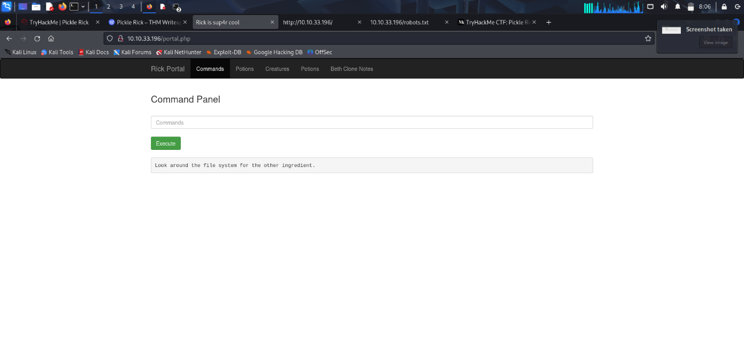
It says that we have to look around the file system for the next clue
Navigate to home using ‘ls /home’ command
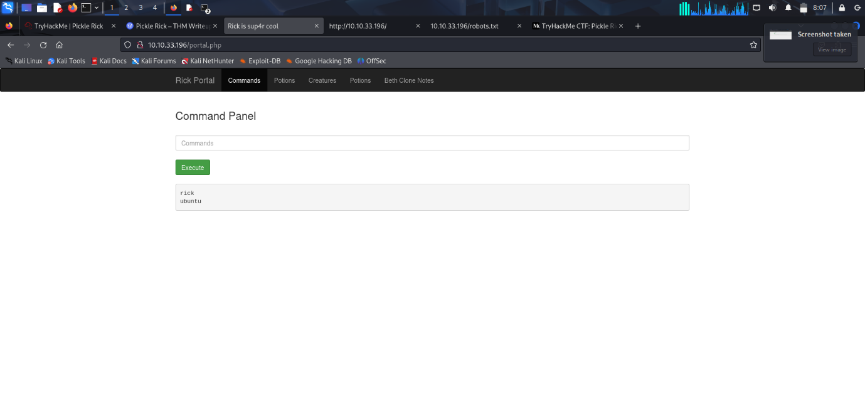
It shows 2 directories ‘ubuntu’ and ‘rick’ . The “ubuntu” directory seems like a default directory on the Linux system itself but the “rick” directory is most certainly a configured user.
Navigate and list all the files inside ‘rick’ directory using ‘ls /home/rick’ command
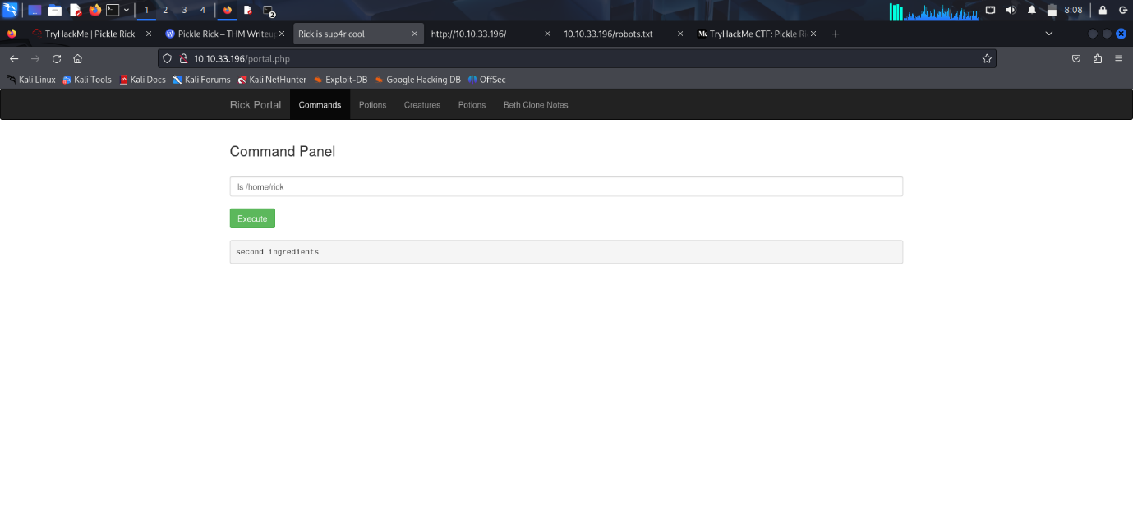
It shows a file named ‘second ingredients’. See the contents of this file using ‘less’ command
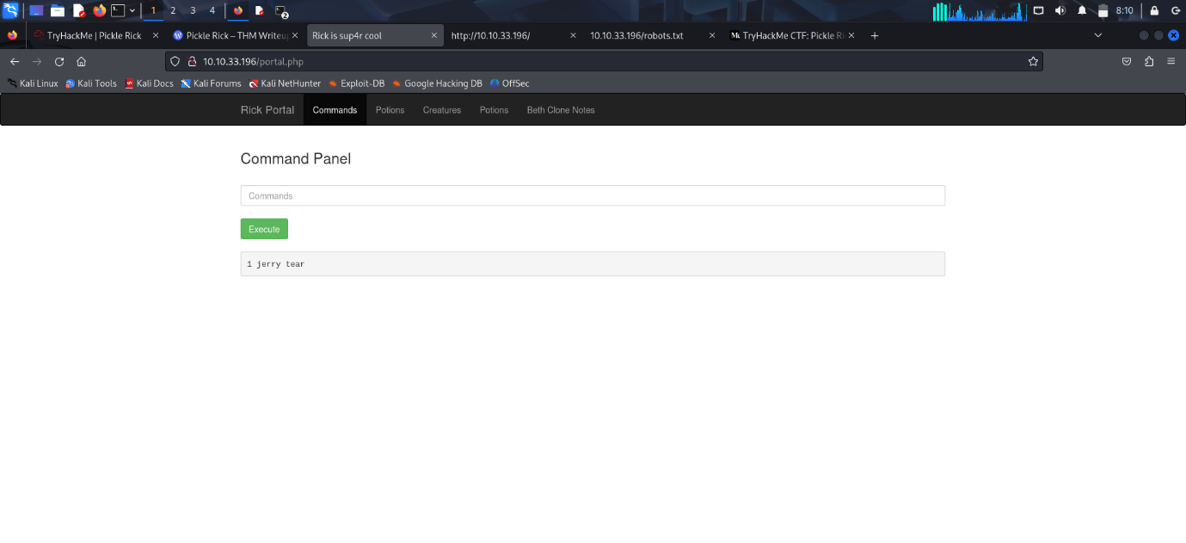
We get the second ingredient ‘1 jerry tear’
For the 3rd ingredient try to access the root directory by using ‘cd /root’ command
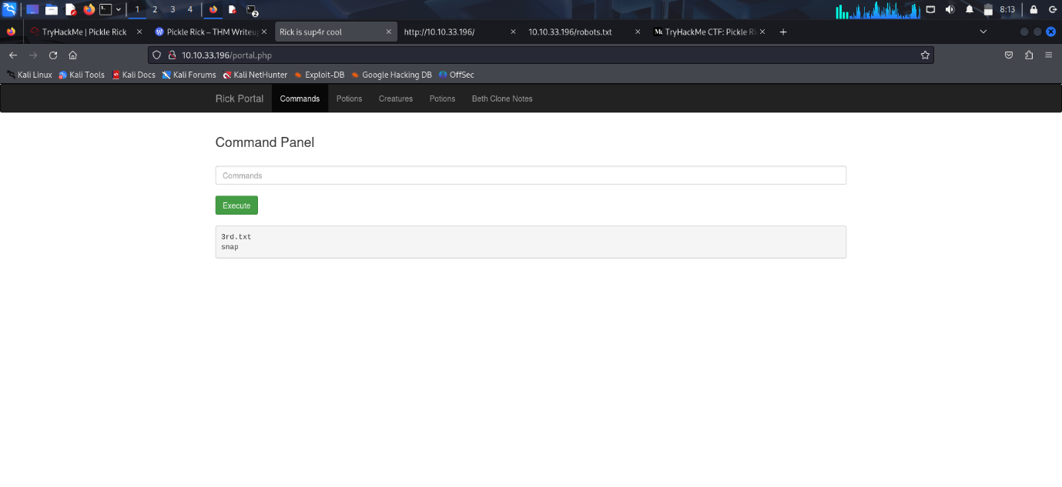
It shows a file named ‘3rd.txt’ . Use the ‘sudo less /root/3rd.txt’ command to see the contents
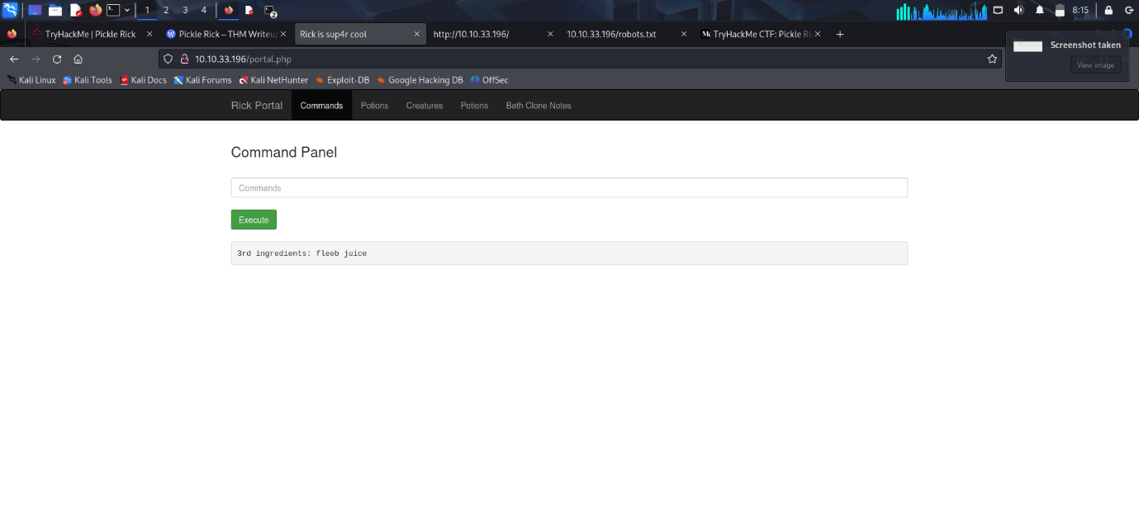
We get the final ingredient ‘fleeb juice’

Conclusion
The Pickle Rick room is a simple and fun challenge for beginners. It helps you learn how to:
- Find hidden pages on a website
- Use easy/default usernames and passwords
- Explore a Linux system using a web shell
- Get root (admin) access by using sudo
We found all three ingredients Rick needed by checking different files on the system.

